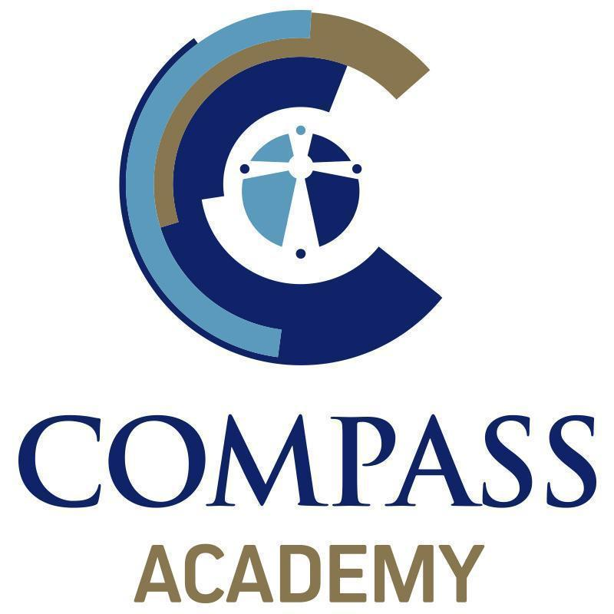
The Compass Academy Referral Form
Referrers Details
Name | Claire Horne / Emma Davidson | Organisation | The Compass Academy
Contact Number | 01482 331720 | Address | Snowdon Way,  Hull
Fax No
Email Address | c.horne@com.hslt.academy / e.davidson@asp.hslt.academy | Postcode | HU7 5DS

Young Person’s Details
Name |  | Parent/carer
Address |  | DOB
 |  | Age
 |  | NC Year
Male/Female |  | Ethnic Origin
UPN Number |  | First Language
Agency involvement?

Young Person’s Emergency Contact and Consent Form
Name |  |  | Parent/Carer
Telephone number |  |  | Mobile
Address
Course Consent
I give my permission for ……………………………………………………… to take part in this course, which may include taking part in activities off-site.

Marketing and Research Consent
I give my consent for any photographs or video footage recorded during the course to be used in promotional material, by the organisation and funders. I agree to any findings from the project being shared publicly.

Medical Consent
In the event of any accident or illness, I consent to any necessary medical treatment, by a recognised qualified person providing that every effort has been made to contact me and failed and if the delay in obtaining my own consent is considered inadvisable by the medical professionals concerned.
Signed |  |  |  | Date

All information recorded in this form will be treated in the strictest confidence
Young Person’s Background: Please tell us as much useful information as possible that will help us when working with this young person.
Reason for referral?

School history – please provide details of the schools the young person has attended.
Primary school(s) attended:

SAT Results |  |  |  | Maths |  |  | English |  | Science
Secondary school(s) attended:

Current levels |  | Maths |  |  |  | English |  | Science
Attendance (this academic year) |  |  |  |  |  | Attendance (previous academic year)
Has the young person ever received a fixed term or permanent exclusion? If so, please provide details below.

Does the young person have any special learning needs? E.g. Dyslexia, large print, basic skills needs

Does the young person have a criminal record or are they subject to any orders? If yes, please provide details below.

Does the young person have any involvement with any agencies? E.g. social services, Youth Offending Team, CAMHS etc. If so please provide details

Does the young person have any medical conditions?

Areas of concern |  |  | Drug/Alcohol Abuse  Suicide/Self-Harming  Violence  Relationships  Arson
If you have ticked one of the above please use this space to provide further information. (Please attach a separate piece of paper if you need to).

How matured is the young person in developing skills?

Any other information you feel is important for us to consider. (Please attach any reports relevant to this application).

Signed |  |  |  |  | Date

